Cloud Functionality Report for Company Y
Introduction
Company Y is a financial services organization specializing in fintech. Company Y seeks a digital transformation that improves customer experience, strengthens big data analytics, maintains regulatory compliance, and supports high-volume real-time transactions. Because financial services organizations handle sensitive customer and transaction data, Company Y needs a highly available, secure cloud infrastructure that leverages virtualization, scalable compute, secure networking, encrypted storage, centralized monitoring, and controls that support compliance.
For this functionality report, Company Y will use the AWS lab environment. The recommended AWS design includes an Amazon EC2 virtual machine running Amazon Linux 2023, encrypted Amazon EBS storage, a secure VPC network configuration, Amazon Linux package repositories, CloudWatch logging and monitoring, and a network analysis tool to validate VM connectivity and performancecl.
A1. Server Operating System Selection
Company Y should use Amazon Linux 2023 as the server operating system for its AWS EC2 instance. Amazon Linux 2023 is appropriate because AWS designed the operating system for cloud workloads running in AWS environments. Amazon Linux 2023 uses the DNF package manager, which allows administrators to install, update, search, and remove packages from the command line (Amazon Web Services [AWS], n.d.-a).
A1a. Selected Operating System and Rationale
Company Y should use Amazon Linux 2023 as the server operating system for its AWS EC2 instance. Amazon Linux 2023 is appropriate because AWS designed the operating system for cloud workloads running in AWS environments. Amazon Linux 2023 uses the DNF package manager, which allows administrators to install, update, search, and remove packages from the command line (Amazon Web Services [AWS], n.d.-a).
Amazon Linux 2023 is a strong choice for Company Y because it supports secure cloud operations, integrates well with AWS services, and avoids additional operating system licensing costs compared to some commercial operating systems. The operating system also supports common server roles, including web servers, monitoring agents, security tools, and network troubleshooting utilities.
For Company Y’s financial services workload, Amazon Linux 2023 provides a practical balance of security, cost efficiency, compatibility, and operational simplicity. The company can use the operating system to host a web application, run monitoring tools, install required packages, and support encrypted storage and logging.
1b. CPU and memory requirements
Company Y should use a t3.medium EC2 instance because the T3 family provides newer burstable general-purpose performance for workloads with moderate CPU usage and temporary traffic spikes, making it appropriate for a small financial services web server, monitoring agent, and network testing workload.
A t3.medium is equipped with 2 vCPUs and 4 GiB of memory, which is sufficient for Company Y’s expected lab workload because the server will support a lightweight web application, basic system services, monitoring agents, encrypted storage, and network testing tools. The 2 vCPUs provide enough processing capacity for moderate web traffic, package updates, log collection, and basic troubleshooting commands, while the 4 GiB of memory gives the operating system, web server, and monitoring tools enough RAM to run smoothly without overcommitting resources. Since this environment is intended for a controlled cloud functionality report rather than a full production banking platform, the t3.medium instance provides a balanced and cost-effective starting point. If Company Y’s transaction volume, user traffic, or analytics workload increases later, AWS can scale the instance vertically to a larger size or horizontally by adding more instances behind a load balancer.
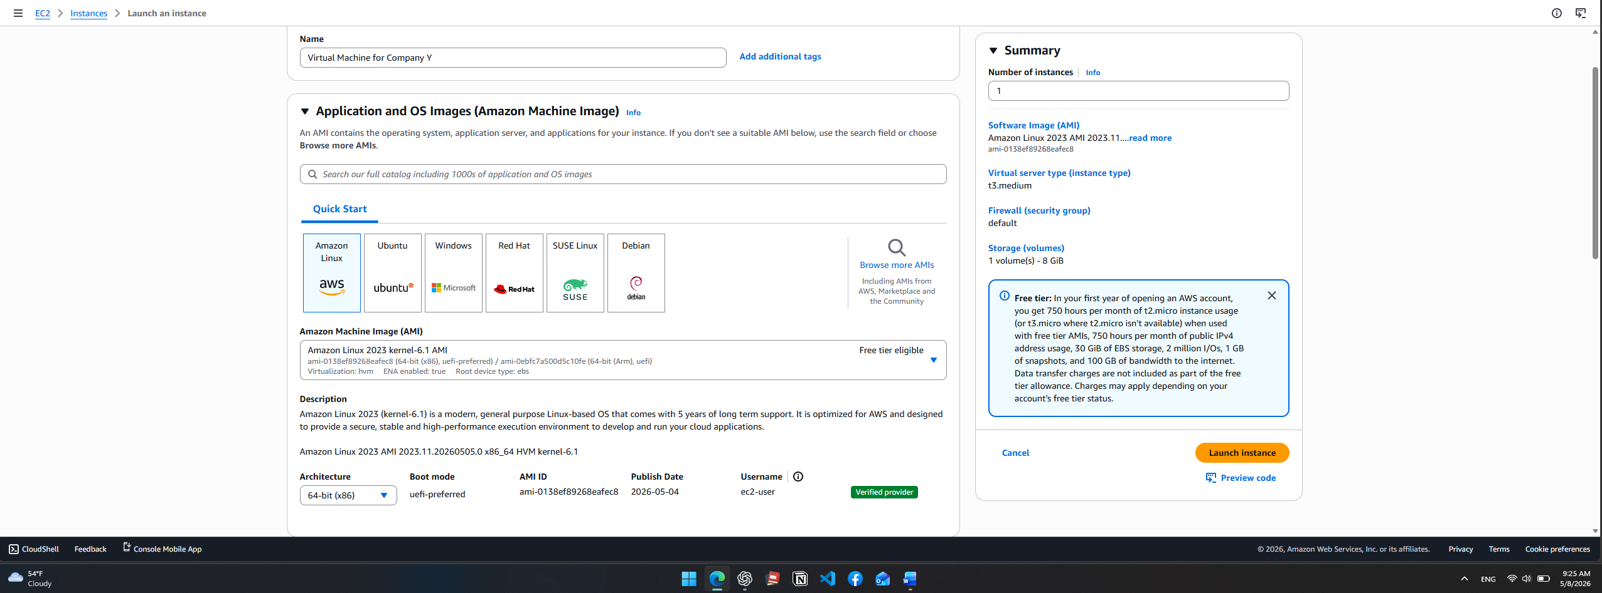
Illustration 1c: AWS virtual machine created at 1:50 PM 05/07/2025
2. VM Encrypted Storage Configuration
2a. Encryption Method and Rationale
Company Y should use Amazon EBS encryption with AWS Key Management Service (AWS KMS) for the VM’s storage encryption. Amazon EBS volumes function like virtual hard drives attached to EC2 instances, so encrypting EBS storage helps protect the server’s operating system files, application files, logs, and any sensitive financial data stored on the VM.
Amazon EBS encryption is the best choice for Company Y because AWS designed it specifically for EC2 storage. EBS encryption uses AWS KMS keys when creating encrypted volumes and snapshots, and AWS handles the encryption process without requiring Company Y to build or maintain a separate key-management system. AWS also encrypts data at rest on the volume and data moving between the EC2 instance and its attached EBS storage.
Company Y should use a customer-managed KMS key instead of only relying on the default AWS-managed key when possible. In this case, a lab environment is deployed for demonstration purposes, so the default aws/ebs KMS key will be selected. A customer-managed key gives Company Y more control over key permissions, rotation, access policies, and auditing. Amazon EBS uses AWS KMS to encrypt volumes and snapshots, and encrypted snapshots remain encrypted when created from encrypted volumes.
For a financial services company, this encryption method supports confidentiality, compliance readiness, and operational control. In simple terms, EBS encryption works like locking the VM’s hard drive in a secure vault. Even if someone could access the underlying storage, the data would remain protected without the correct encryption key.

2b. Step-by-Step: Configure EBS Encryption on the VM Storage
Step 1: Open the AWS Console
- Sign in to the AWS Management Console.
- Make sure you are in the correct AWS Region.
- Search for EC2.
- Open the EC2 Dashboard.

Step 2: Enable EBS Encryption by Default
This is a best practice because it helps prevent someone from accidentally creating an unencrypted volume later.
- In the EC2 console, scroll down the left menu.
- Go to Account attributes.
- Click EBS encryption or Data protection and security.
- Click Manage.
- Turn on Always encrypt new EBS volumes or EBS encryption by default.
- Choose the default KMS key:
- Click Save changes.
AWS states that Amazon EBS encryption uses AWS KMS keys to encrypt EBS volumes and snapshots, and encryption protects data at rest and data moving between an EC2 instance and its attached EBS storage.
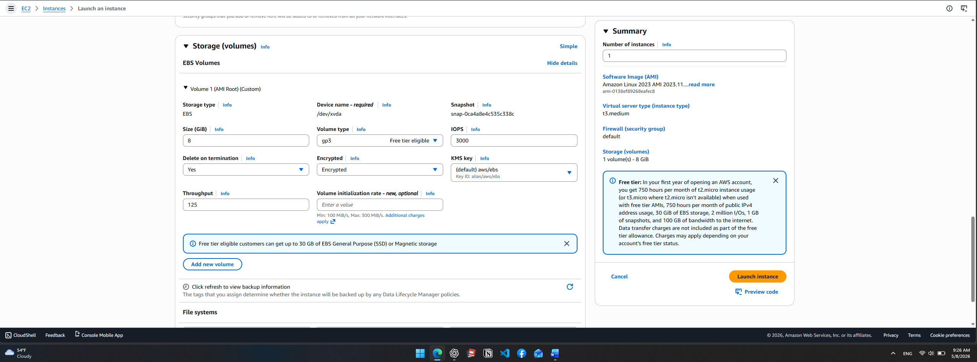
A3. Network Topology Architecture
A3a. Assign Static or Dynamic IP Addresses to the VMs and Rationale
For Company Y, I recommend using static private IP addresses for critical VMs and avoiding direct public IP addresses for production servers whenever possible.
In AWS, every EC2 instance receives a private IP address from the subnet where the instance is launched. AWS explains that private IPv4 addresses are used for communication between instances inside the VPC and are not directly reachable from the internet (Amazon Web Services [AWS], n.d.-a). For Company Y, private IP addresses are important because financial systems should not be directly exposed to the public internet.
Company Y should use static private IP addresses for important servers such as web/application servers, monitoring servers, and database servers because static addressing makes the environment easier to manage. Security groups, firewall rules, monitoring dashboards, DNS records, and troubleshooting documentation can reference consistent IP addresses. In simple terms, a static IP is like giving a server a permanent office number. Engineers always know where to find it.
For public-facing access, Company Y should use an Application Load Balancer instead of placing public IP addresses directly on application servers. The load balancer can receive HTTPS traffic from customers and forward approved traffic to EC2 instances in private subnets.
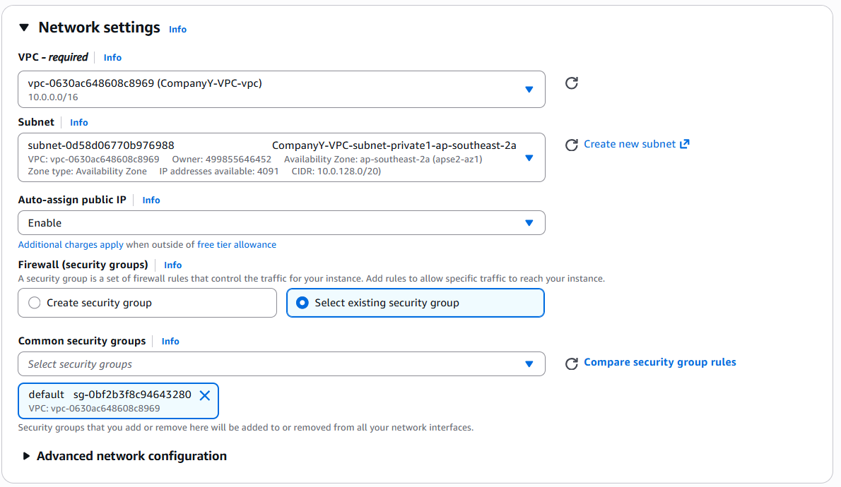
A4. OS Package Repository Setup
A4a. Enable System Services Required for the Server’s Role
Company Y should use the default Amazon Linux 2023 DNF package repositories to install and manage the packages required for the EC2 server’s role. Amazon Linux 2023 uses DNF as the default package management tool, replacing YUM for most package-management tasks (Amazon Web Services [AWS], 2026a). The server’s role is to function as a monitored web server, so Company Y should enable the services required for secure administration, web hosting, network connectivity, and monitoring.
The required services include sshd for secure remote administration, nginx for web server functionality, and amazon-cloudwatch-agent for monitoring and log collection. AWS states that the CloudWatch agent can collect metrics, logs, and traces from EC2 instances, which makes it appropriate for tracking VM health and supporting troubleshooting.
Service | Purpose | Why Company Y Needs It
sshd | Secure remote administration | Allows authorized administrators to connect securely to the VM
nginx | Web server | Hosts the basic web application or landing page
amazon-cloudwatch-agent | Monitoring and logging | Sends system metrics and logs to Amazon CloudWatch
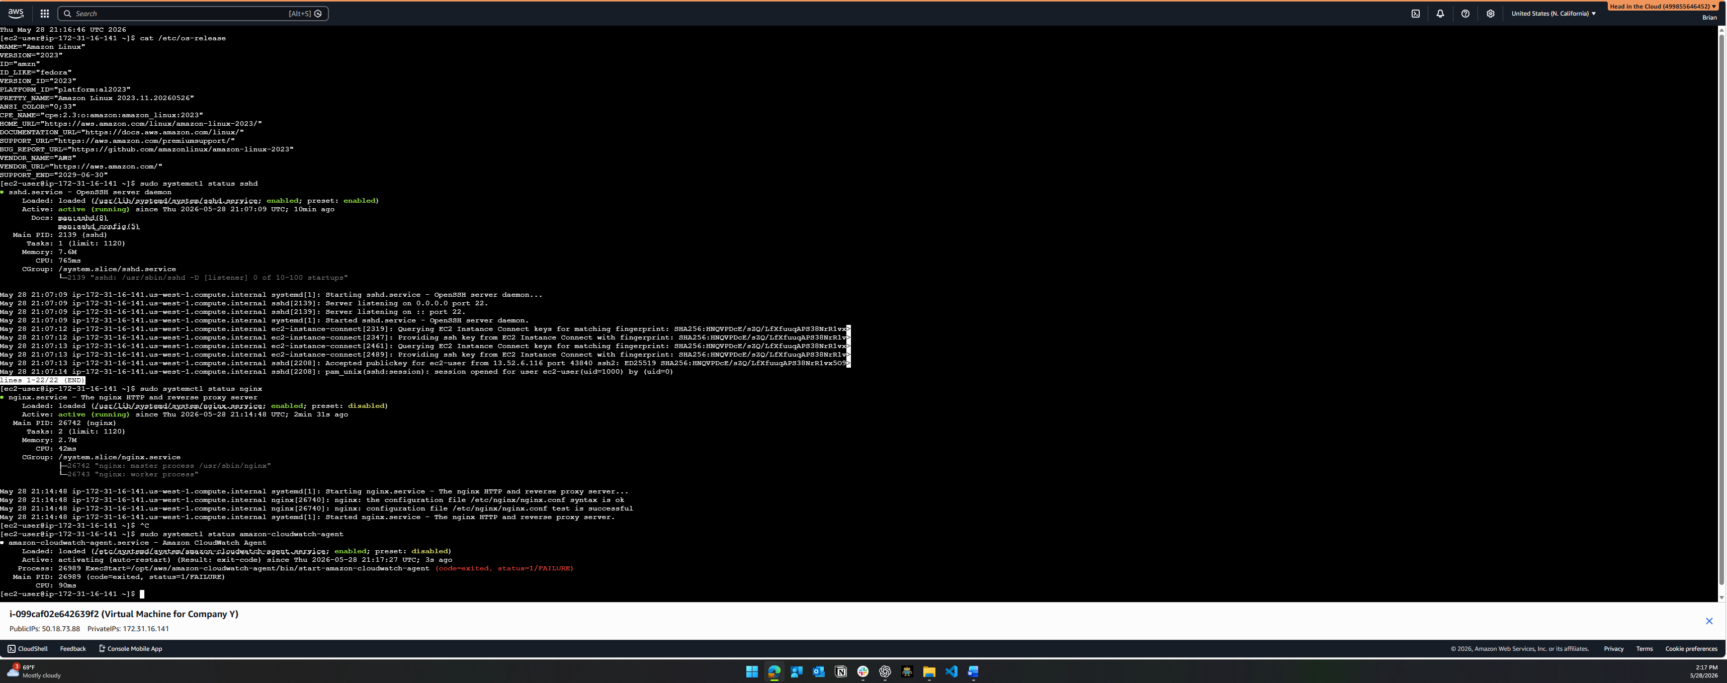
A5. System Logging Configuration
A5a. Configure a Monitoring Solution to Track VM Performance and Alert on Issues
Company Y should configure Amazon CloudWatch with the CloudWatch Agent to track VM performance, collect system logs, and alert administrators when issues occur. CloudWatch is appropriate for Company Y because it can monitor EC2 performance, collect logs from the operating system, display metrics on dashboards, and create alarms for conditions such as high CPU usage, low disk space, or failed instance checks. AWS states that the CloudWatch Agent can collect detailed system metrics, including CPU, memory, disk usage, network performance, logs, and traces from EC2 instances and on-premises servers. For Company Y, the monitoring solution should track:
Metric or Log | Purpose
CPU utilization | Identifies high compute usage
Memory usage | Detects memory pressure
Disk usage | Prevents storage exhaustion
Network in/out | Monitors traffic volume
EC2 status checks | Detects VM or host-level failures
/var/log/messages | Collects system activity logs
/var/log/secure | Tracks authentication and security events
NGINX access/error logs | Monitors web server activity

